**Castle Scene** *(AKA: Hero Demo)*

*CI5525: 3D Graphics Coursework - Level 3 Project*

Project Report

*Mac Baranowski – K2120853*

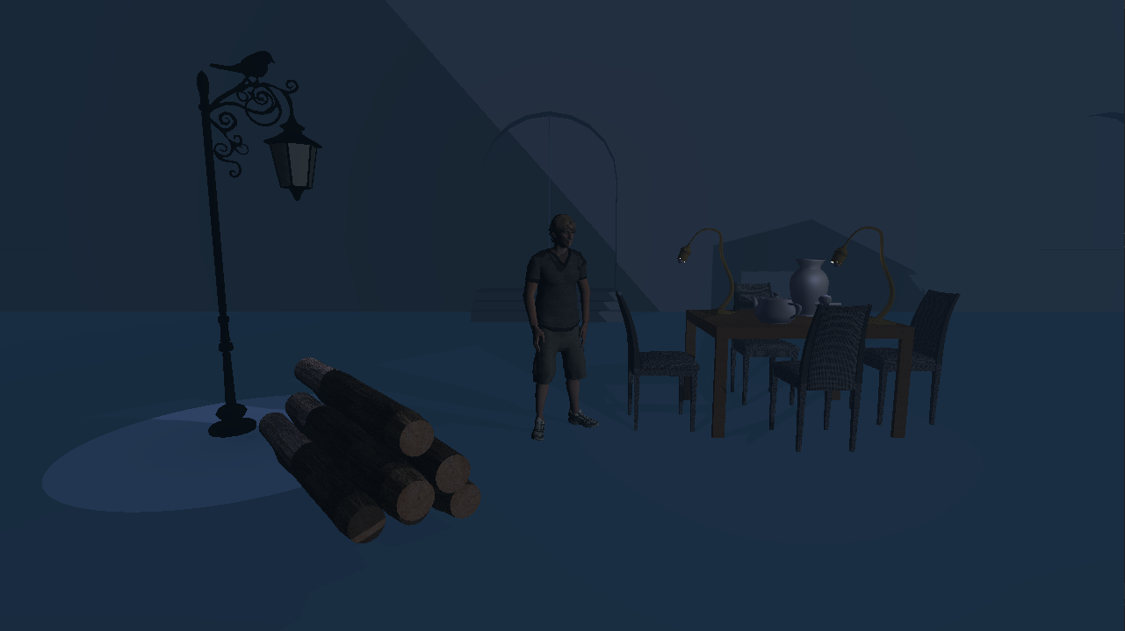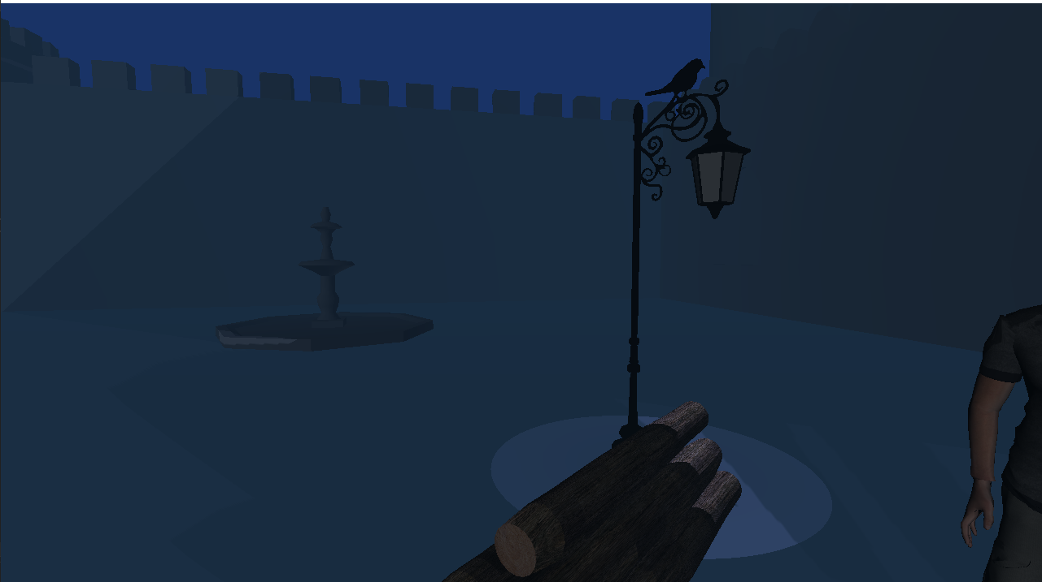

***Scene design:***

The scene features a predominantly navy colour palette. The sky and the fog feature a similar colour, but not exactly the same in order to distinguish between the two. Considering the scene is a castle scene, a Victorian-style lamp has been used that illuminates a stack of wooden logs via a spotlight.

***3D techniques:***

Fog has been implemented to create a hazy ambiance. A spotlight has been used to illuminate the logs in a way that contrasts the shadows in a pleasant way. The shadows are used to create a depth effect for the castle walls and the logs. Normal mapping has been attempted but has not worked. Specular point lights illuminate the table. Several external OBJs with MTLs have been used to create a scene unique to the default ones used in previous levels.

***Source code:***

Multiple functions are implemented to render the shadows. The OnRender() function has been moved around in the main.cpp in order to make the shadow functions work appropriately. Pre-initialisation was originally used, but moving the function proved to be more effective.